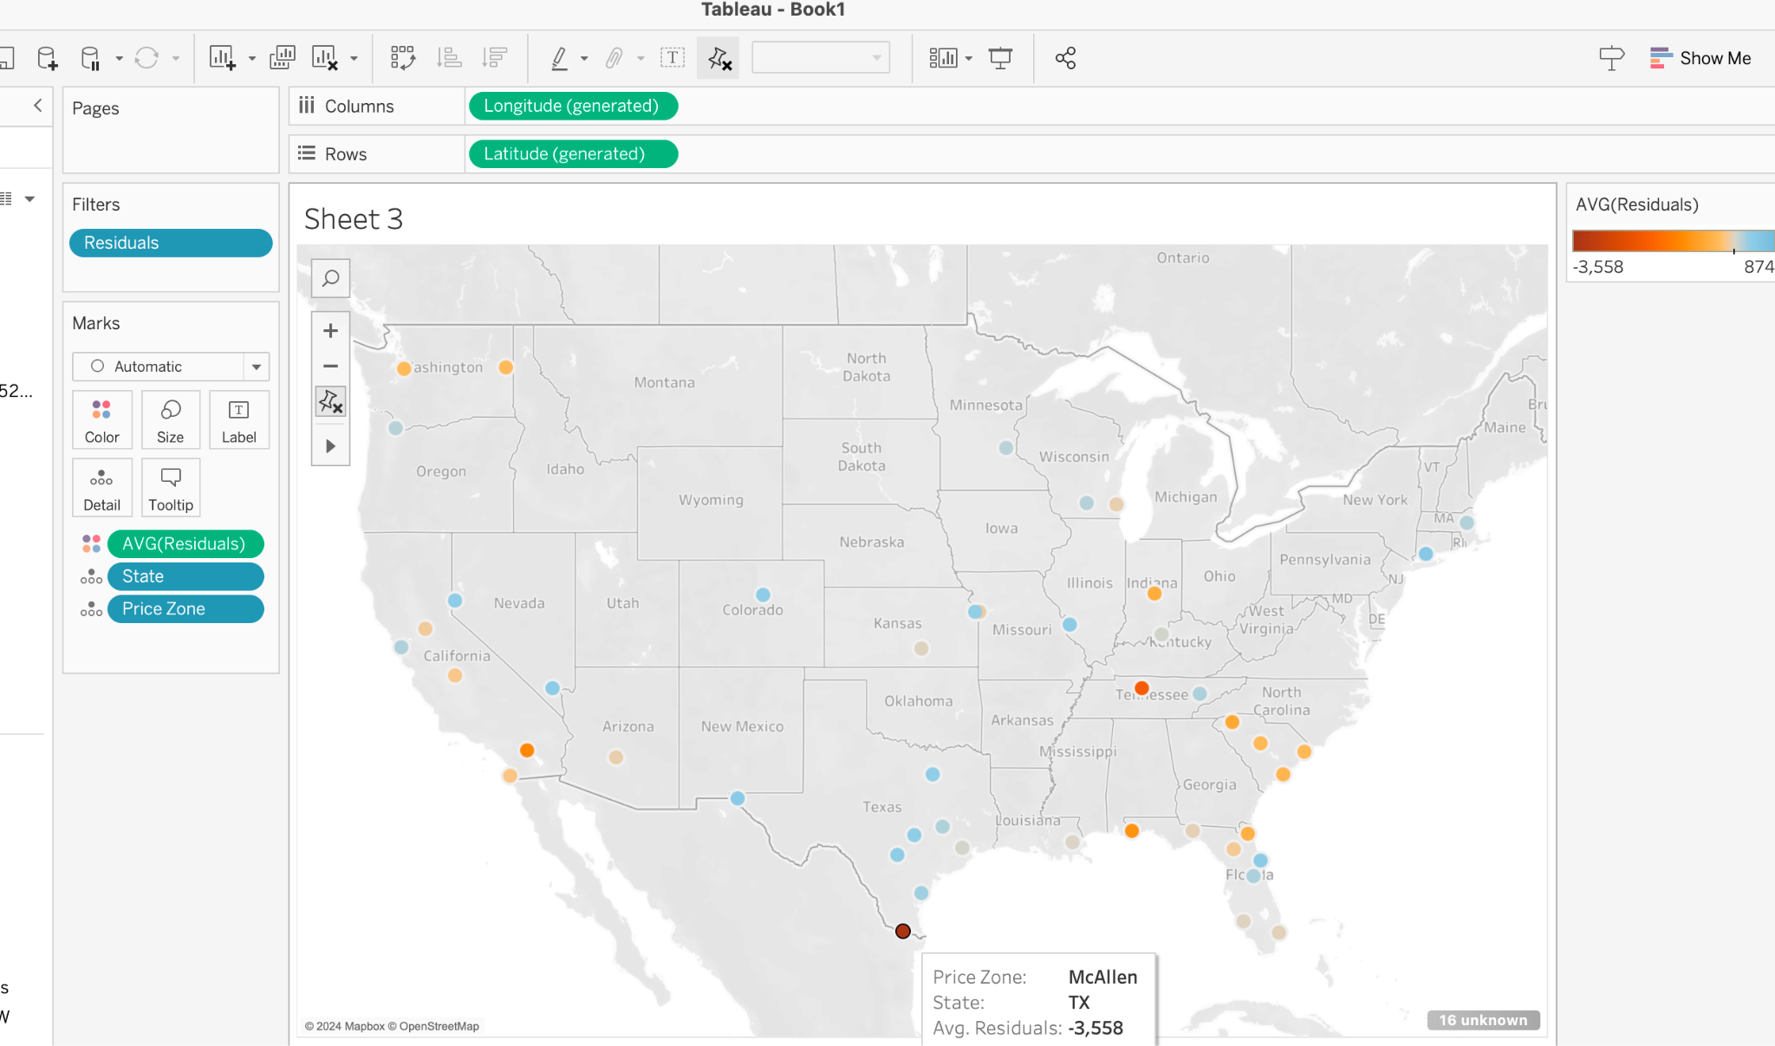

By price zones not much- except mcallen, texas and nashville Tn seems to be underperforming

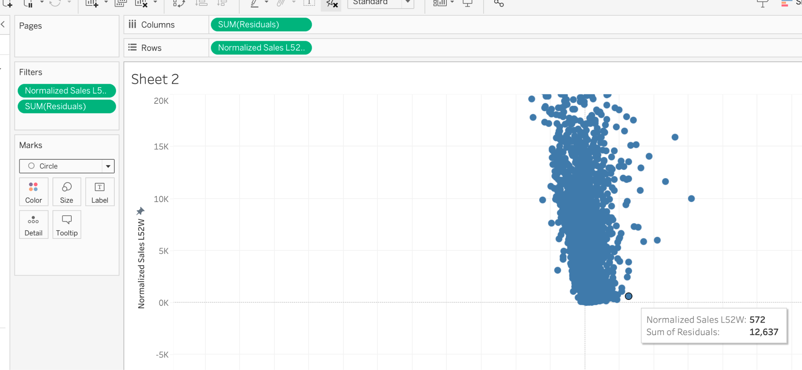

Normalized sales vs residuals– there are a few outliers

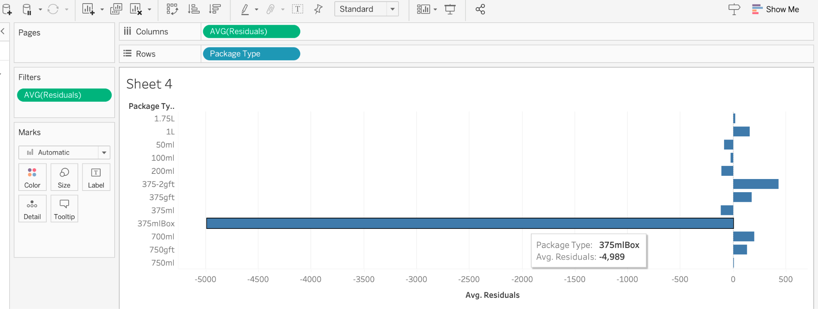

Package type 375mlBox underperforming

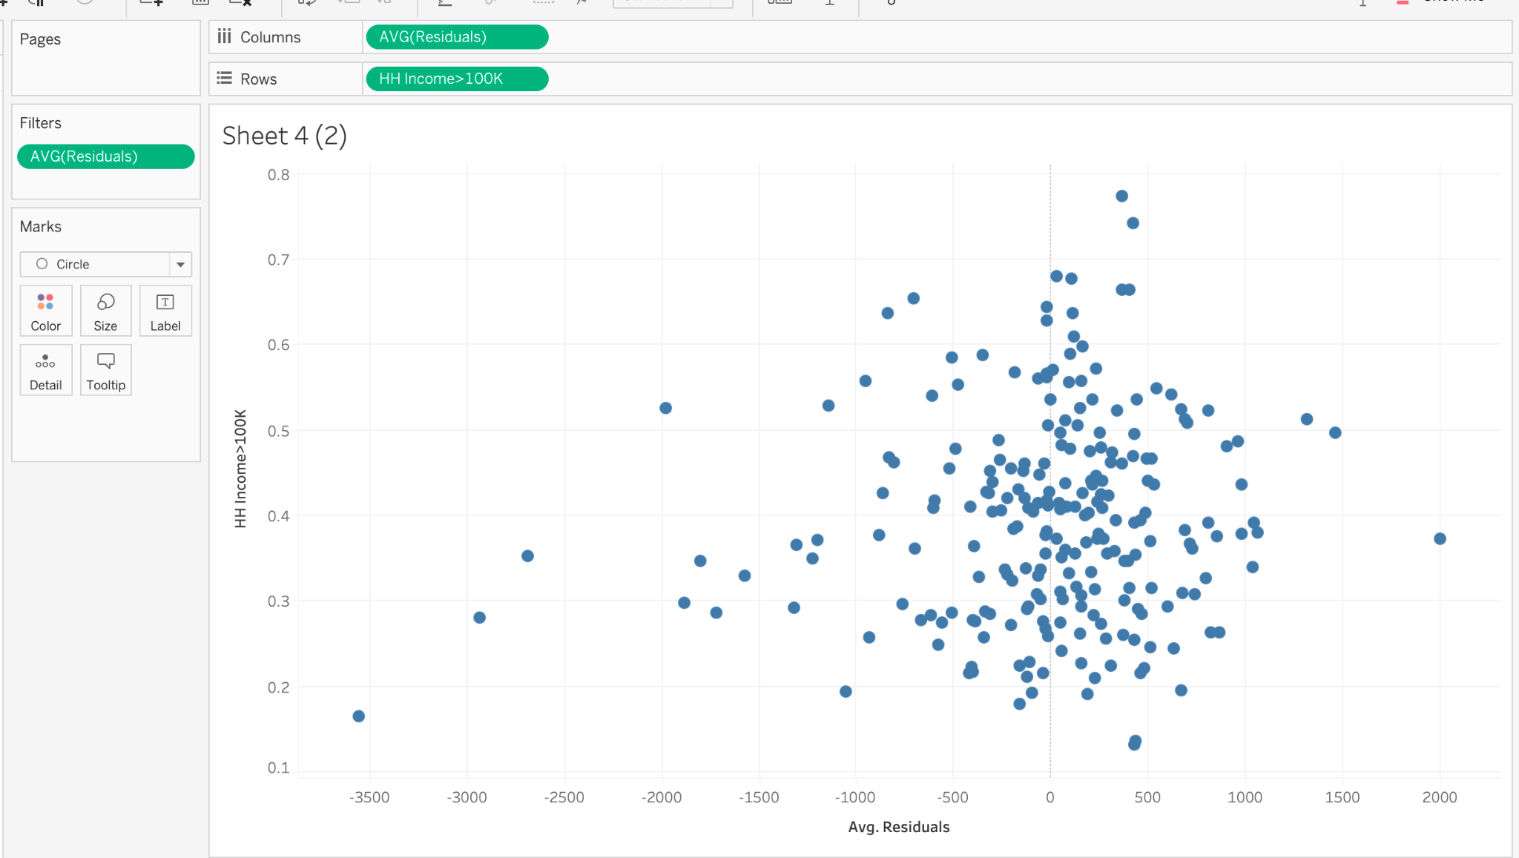

For most of the demographic features they often have underperforming outliers in that max -3000 range

Normalized households generated a greater range off noisy outliers

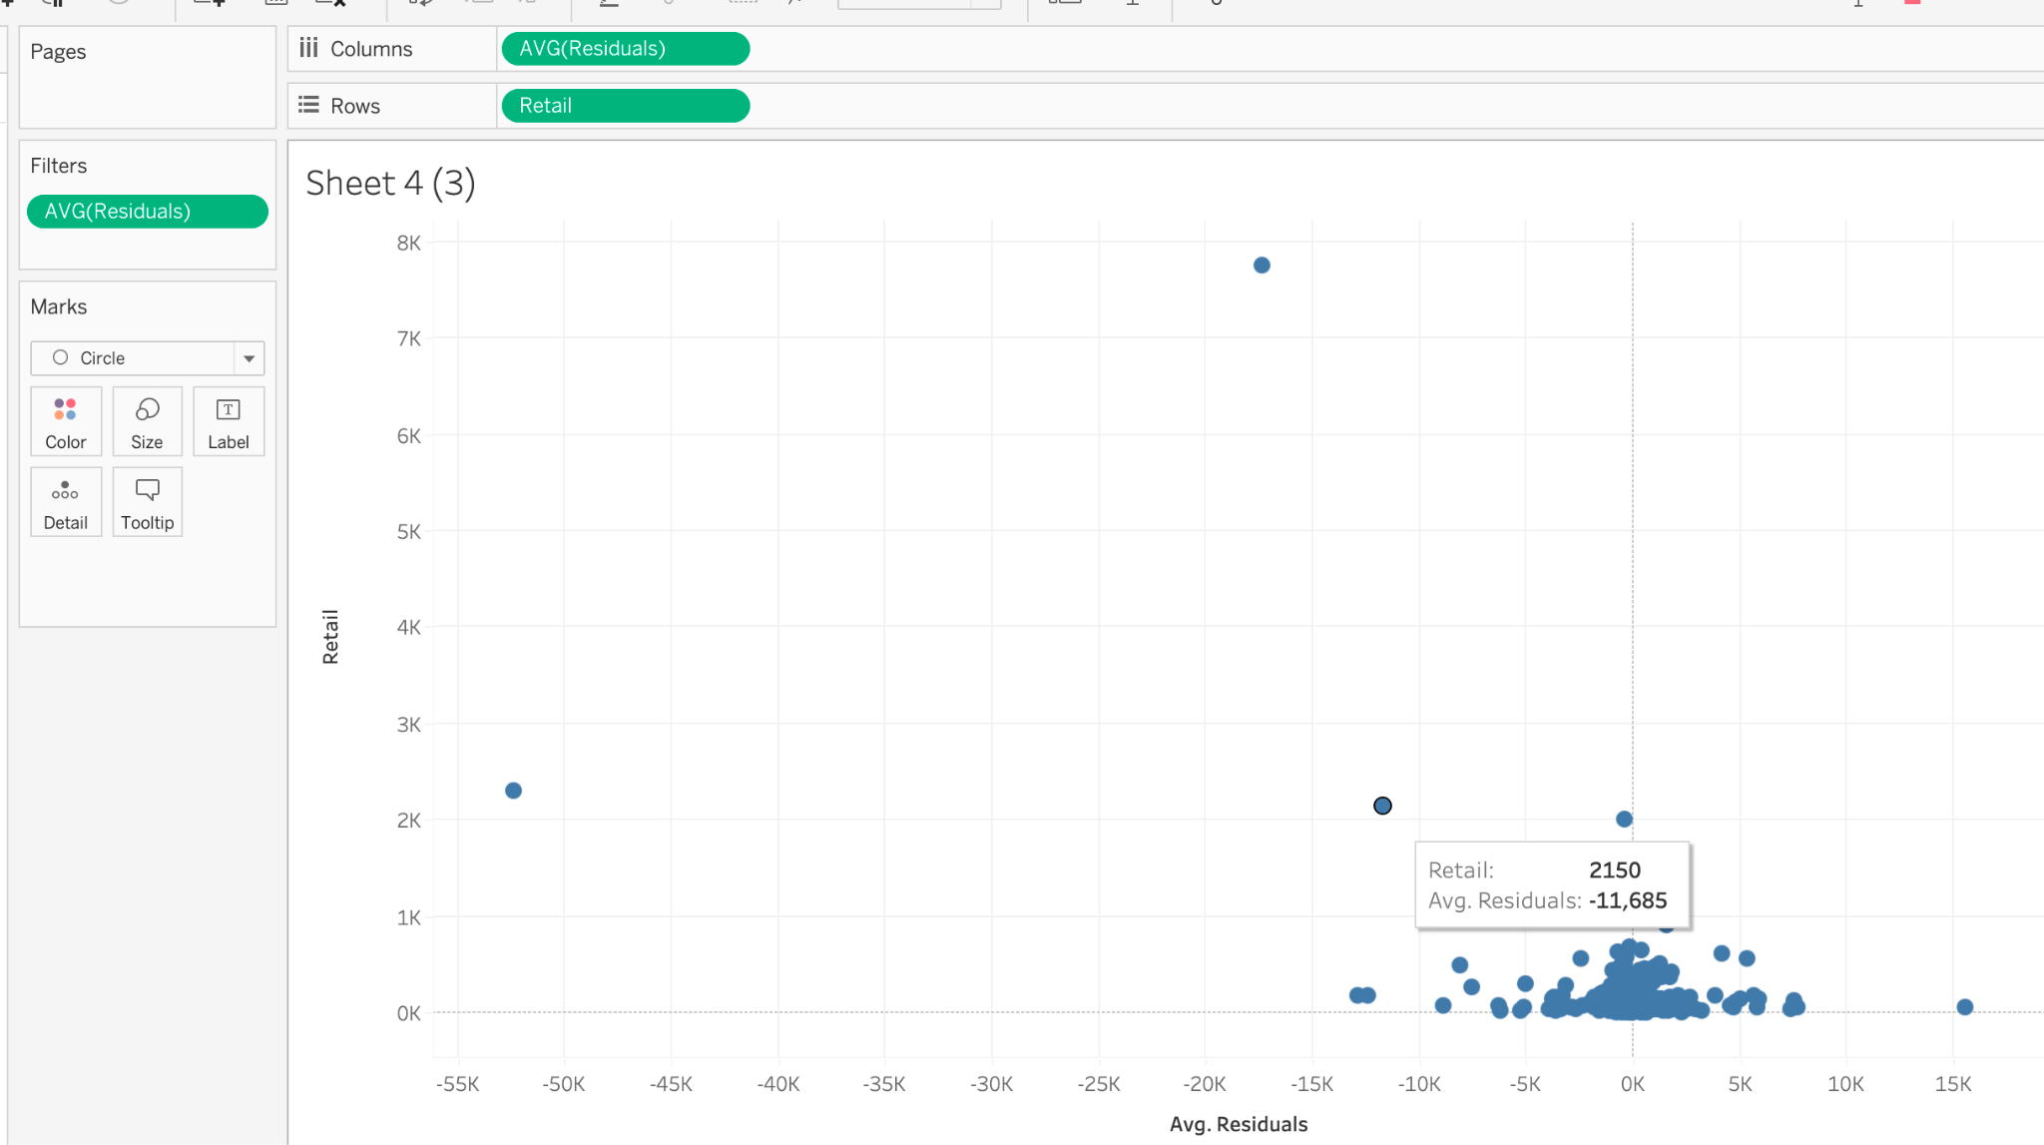

Those with a really high retail price we underperformed

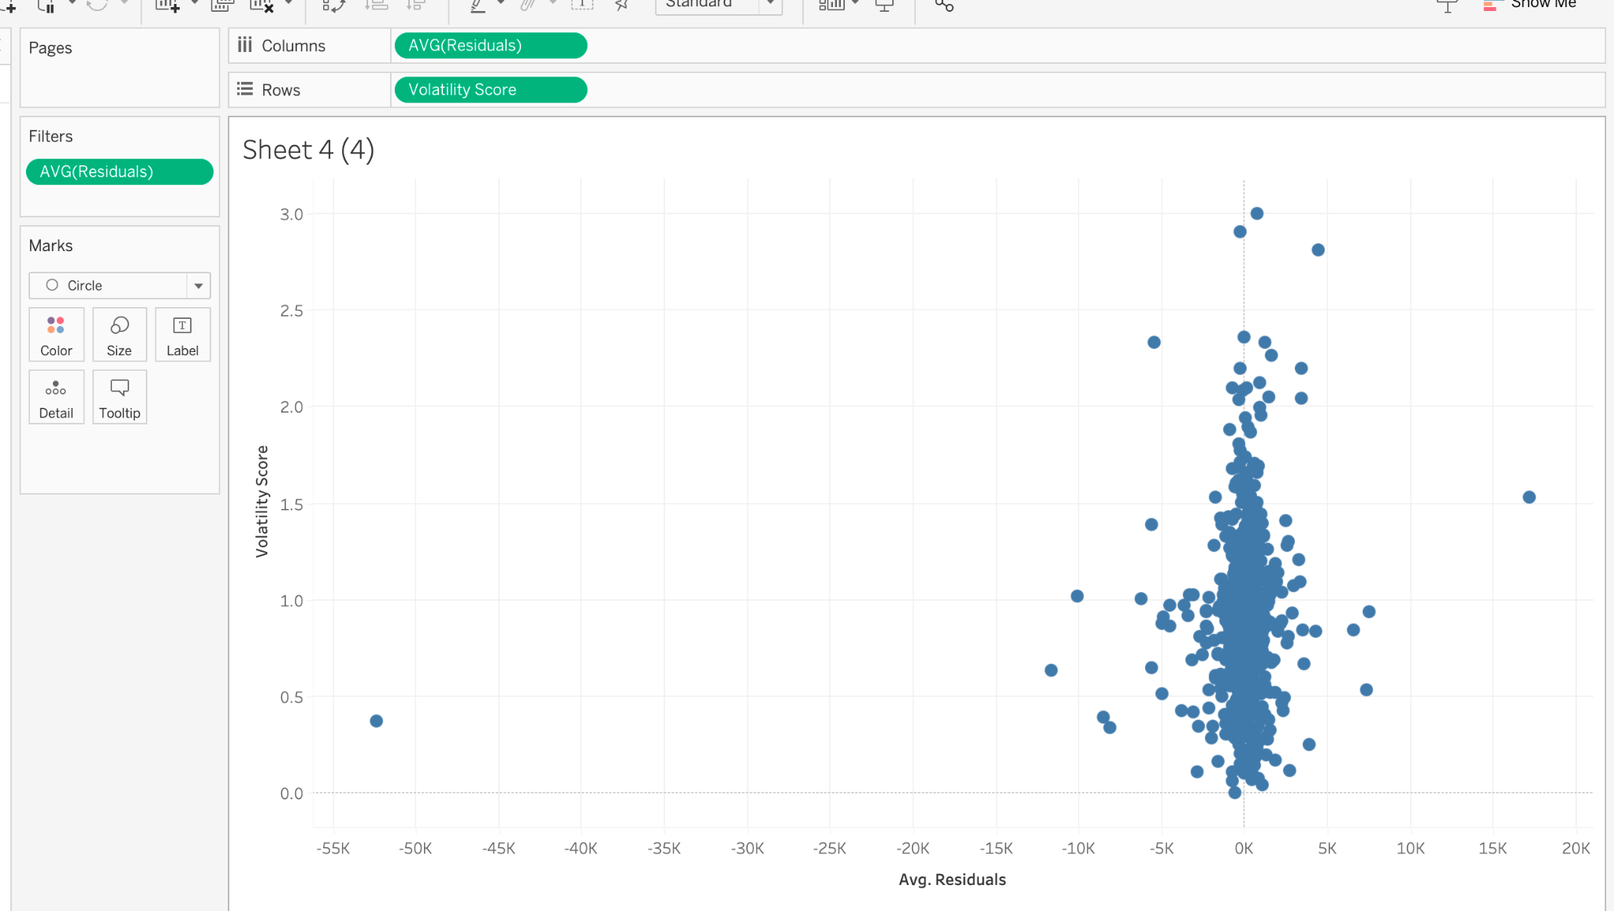

Volatility score had some high outliers